ECA1 Series
Bus type open and closed loop stepper driver

User Manual V1.0.0
Applicable to EC1-57E and ECA1-86E
Table of contents

1. Product Introduction 4
1.1 Product Overview 4
1.2 Product Features 4
1.3 Networking Solution 5
2. Installation dimensions and interface definition 5
2.1Mechanical installation drawing 5
2.2 Installation Notes 6
2.3 Specifications 6
2.4 Operating environment and parameters 6
3. Driver interface and wiring description 7
3.1 Driver Interface Introduction 7
3.2 Indicator Lights 7
3.3 Communication Interface 8
3.4 Input Signal Interface 8
3.5 Output signal interface 9
3.6 DIP switch definition 9
4. Parameter description and settings 10
4.1 All parameters 10
4.1.1 Communication parameters 10
4.1.2 Manufacturer-defined parameters 12
4.1.3 CIA402 parameter group 27
4.2 IO function configuration 32
4.2.1 Input Signal 32
4.2.2 Output Signal 33
5. Common functions 33
5.1 Parameter saving and restoring factory settings 33
5.2 Control word and status word bit definition 34
5.2.1 0x6040 Control Word 34
5.2.2 0x6041 Status Word 34
5.3 Control Mode and Associated Object Dictionary 34
5.4 State transition of each mode control operation 35
5.5 Return to origin mode 36
5.5.1 Method 1 and Method 2 36
5.5.2 Method-3 and Method-4 37
5.5.3 Method-5 and Method-6 38
5.5.4 Method 1 and Method 2 38
5.5.5 Method 3 and Method 4 39
5.5.6 Method 5 and Method 6 39
5.5.7 Method 7 and Method 8 40
5.5.8 Method 9 and Method 10 40
5.5.9 Method 11 and Method 12 41
5.5.10 Method 13 and Method 14 41
5.5.11 Way17and methods18 42
5.5.12 Method 19 and Method 20 43
5.5.13 Method 21 and Method 22 44
5.5.14 Method 23 and Method 24 44
5.5.15 Method 25 and Method 26 45
5.5.16 Method 27 and Method 28 46
5.5.17 Method 29 and Method 30 47
5.5.18 Method 33 and Method 34 47
5.5.19 Method 35 and Method 37 47
6.Fault codes and indicator lights 48
6.1 Drive Failure 48
6.2 ECAT communication alarm 48
6.3 Troubleshooting 49
7. Serial port download parameter description 51
8. Warranty and after-sales 51
8.1 Warranty 51
8.1.1 Free warranty 51
8.1.2 Warranty Exclusion 51
8.2 Exchange 51
8.2.1 Product Replacement for Faulty Products 51
8.2.2 Exchange for non-product failure 52
8.3 Returns 52
8.4 After-sales Service 53
9.Version Revision History 53

Product Introduction

1.1 Product Overview
The ECA1 series bus-type open- and closed-loop stepper drives utilize the EtherCAT bus communication interface, integrating EtherCAT slave technology, vector control technology, built-in micro-segmentation technology, and adaptive filtering technology. This enables real-time control and data transmission of the stepper system, optimizing the performance of the stepper motor: excellent smoothness and ultra-low noise at low and medium speeds; greatly enhanced high-speed torque, expanding the speed application range of the stepper motor; and smooth, precise pure sinusoidal current vector control technology effectively reduces motor heating.
The ECA1 series bus-type open- and closed-loop stepper drivers have perfectly supported the master control systems of many companies, including Beckhoff, Omron, Keyence, Inovance, and Xinje, and have been widely used in industries such as textiles, robotics, lithium battery equipment, 3C electronics, new energy, photovoltaic equipment, medical equipment, and testing equipment.

1.2 Product Features
●New Generation 32-bit RISC-V MCU, high cost performance, good stability, and excellent noise and vibration performance
●Adopt EtherCAT slave technology, support CIA301 and CIA402 sub-protocols, support CSP, PV, PP, HM modes
●Users can set the current, subdivision and lock current through EtherCAT bus or serial communication.
●Built-in single-axis controller function: users can set synchronous position mode, speed mode, position mode, and homing mode through the bus
●3-way opto-isolated programmable input interface, Receive external control signals, Realize drive limit, origin, emergency stop, probe and other functions
●Built-in micro-segmentation and motor parameter setting
●Support OTA firmware upgrade
●Any current reduction ratio can be set when stationary
●With overvoltage, undervoltage and other protection functions
●Good stability, excellent noise and vibration performance
●Support position control, Speed ​​control mode
●Pure sinusoidal current vector control effectively reduces motor heating
●1 opto-isolated programmable output interface, output driver status and control signals
●There is arbitrary subdivision adjustment, and the subdivision can be changed at will
●Excellent stability at low frequencies and small subdivisions

1.3 Networking Solution
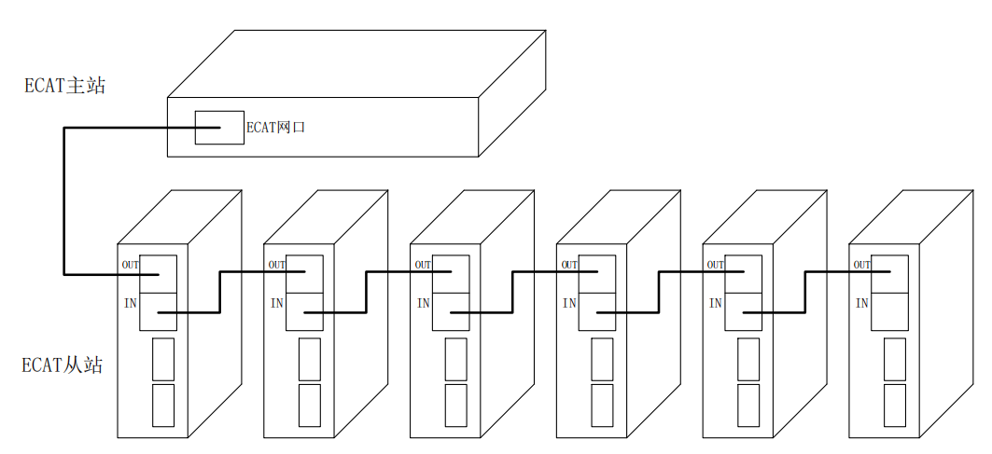
Figure 1 Bus-type stepping network solution

Installation dimensions and interface definition

2.1Mechanical installation drawing
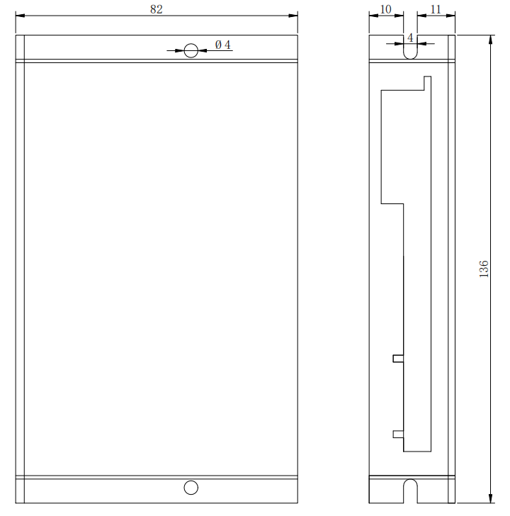
Front installation diagram | Side installation diagram
Figure 2.1 Installation dimensions (unit: mm)

2.2 Installation Notes
- When installing the driver, please install it sideways for better heat dissipation. When designing the installation dimensions, consider the terminal size and wiring.
- In order to ensure good heat dissipation conditions, a larger installation interval must be reserved as much as possible during actual installation. If necessary, install a fan near the driver inside the machine to create strong air convection on the bottom of the driver to assist in heat dissipation and ensure that the driver operates within a reliable operating temperature range.

2.3 Specifications
parameter | EC1-57E | ECA1-86E
Matching motor | 20/28/42/57/60 base | 57/60/86 base
Input voltage | DC24~48V | DC24~80V, AC20~55V
Input signal | Origin, positive limit, negative limit, emergency stop, probe
Output signal | Alarm output, in-position output, Z-phase output, motor enable output, free output

2.4 Operating environment and parameters
Cooling method |  | Natural cooling, fan cooling
Usage Environment | occasion | Do not place it near other heating equipment. Avoid dust, oil mist, corrosive gas, high humidity and strong vibration. Flammable gas and conductive dust are prohibited.
Usage Environment | temperature | -25℃~55℃
Usage Environment | humidity | 40~90%RH
Usage Environment | vibration | 10~55Hz/0.15mm
Storage temperature |  | -25℃~65℃

Driver interface and wiring description

3.1 Driver Interface Introduction
Table 3.1 Driver Interface
name |  | Function | illustrate
ECAT IN/OUT |  | ETHERCAT communication port | ECAT IN:  ECAT OUT: Out
IN/OUT | X0 | Single-ended input | Only supports common anode connection
IN/OUT | X1 | Single-ended input | Only supports common anode connection
IN/OUT | X2 | Single-ended input | Only supports common anode connection
IN/OUT | XCOM | Single-ended input common port  Correct and effective | Low-speed digital signal input interface
IN/OUT | Y0 | Single-ended output | Low-speed digital signal output interface
IN/OUT | YCOM | Single-ended output common port  Compatible with common cathode and common anode | Compatible with both common cathode and common anode connections
Encoder | ENZ+ | Encoder interface | Z signal level detection
Encoder | ENZ- | Encoder interface | Z signal level detection
Encoder | ENB+ | Encoder interface | Connect encoder A and B signals, pay attention to the line sequence
Encoder | ENB- | Encoder interface
Encoder | ENA+ | Encoder interface
Encoder | ENA- | Encoder interface
Encoder | +5V | Encoder power interface | Encoder 5V power supply positive terminal
Encoder | GND | Encoder power interface | Negative terminal of encoder 5V power supply
MOTOR | A+ | Motor interface | Two-phase stepper motor wiring port
MOTOR | A- | Motor interface | Two-phase stepper motor wiring port
MOTOR | B+ | Motor interface | Two-phase stepper motor wiring port
MOTOR | B- | Motor interface | Two-phase stepper motor wiring port
VDC | GND | Power interface | DC20-50V
VDC | VDC | Power interface | DC20-50V

3.2 Indicator Lights
ECA1 series bus type open and closed loop stepper driverThe indicator light is a retracted SMD LED. There is a small round hole on the driver to observe the indicator light status. Its basic definition is shown in Table 3.2 below.
Table 3.2 Definition of indicator lights
name | describe | Function | illustrate
ALM | Red LED | Enable, move, save parameters,  Restore factory settings, alarm, etc. | The red light is off when the power is on normally, the green light flashes slowly for 1000ms when the device is not enabled, the green light is always on when the device is enabled, and the green light flashes quickly for 250ms when the device is in motion.  When saving parameters, restoring factory settings, or when the device is abnormal, the red and green lights will flash to give an alarm. For the flashing pattern, please refer to Chapter 7.
PWR | Green LED

3.3 Communication Interface
ECA1 series bus type open and closed loop stepper driverThe communication interface uses a one-piece standard RJ45 socket, as shown in Figure 3.1. The left port is the input port, connected to the output port of the previous driver; the right port is the output port, connected to the input port of the next driver.
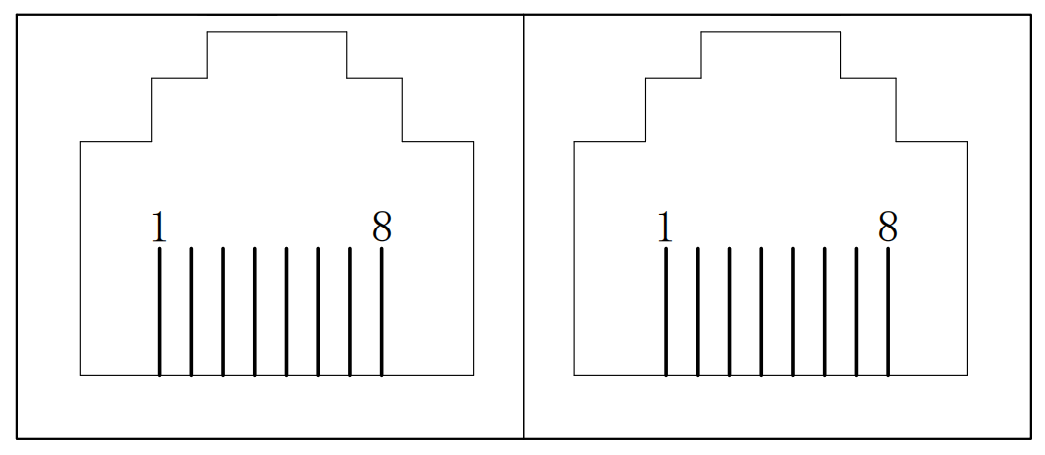
Figure 3.1 Schematic diagram of a one-piece RJ45 interface

3.4 Input Signal Interface
ECA1 series bus type open and closed loop stepper driverProvides a programmable interface with optical isolation input.
The input interface adopts common anode connection and only supports NPN wiring mode. It is connected to +24V externally. To ensure reliable conduction of the optocoupler inside the driver, the driving current on the controller side is required to be at least 10mA, and the input level pulse width needs to be greater than 10ms. Otherwise, the driver may not respond normally. The wiring diagram is shown in Figure 3.2.
After the driver is powered on normally, the effective level of the input interface is initially defaulted to the rising edge or high level.The user can also configure the effective level of the input interface to be initially set to falling edge or low level by default through the master station. For specific configuration, please refer to the definition and description of the registers in Section 4.2.
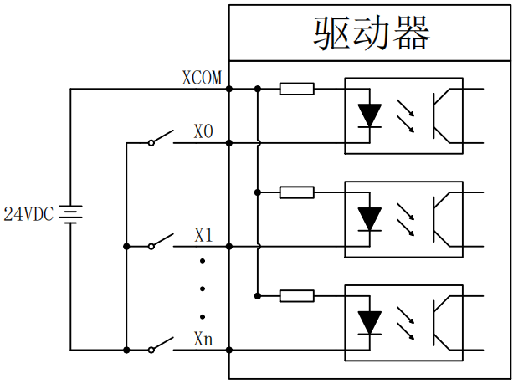
Figure 3.2 Input signal wiring diagram

Note: The default input interface of the ECA1 series bus-type open- and closed-loop stepper driver supports 24V signals. If the user requires 5V signal control, it is necessary to communicate with our sales or technical personnel to make changes.

3.5 Output signal interface
ECA1 series bus type open and closed loop stepper driverProvides a programmable interface with optically isolated output.
The output interface is compatible with common cathode and common anode connection, supports both NPN and PNP wiring, and can support high-level and low-level active master controllers.After the driver is powered on normally, the effective state of the output interface is initially defaulted to normally open output.The user can also configure the effective state of the output interface through the master station to be initially set to normally closed output. For specific configuration, please refer to the definition and description of the registers in Section 4.2.
The following figure is a wiring diagram of the output signal interface:
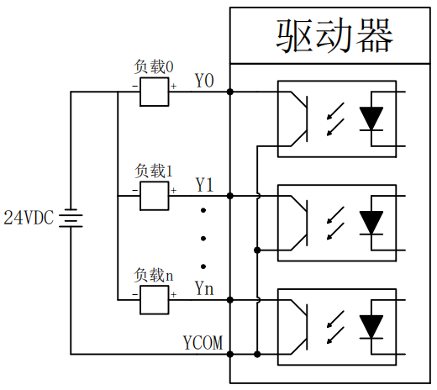 | 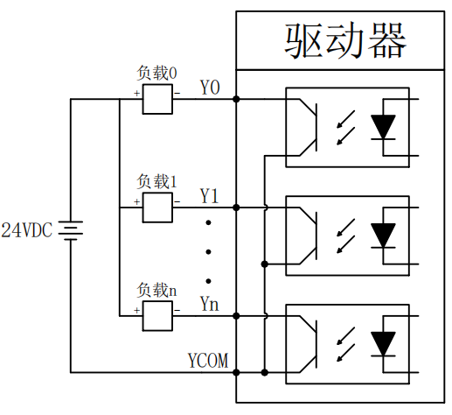
Figure 3.3 Schematic diagram of common anode wiring of output signal | Figure 3.4 Schematic diagram of common cathode wiring of output signal

3.6 DIP switch definition
Dial | state | Function
SW1 | OFF | Driver open loop mode
SW1 | ON | Drive closed loop mode
SW4 | OFF | Clockwise is the positive direction
SW4 | ON | Counterclockwise is the opposite direction

SW2 | SW3 | EC1-57E |  |  |  |  | ECA1-86E
SW2 | SW3 | Open loop (peak) |  | closed loop |  | Open loop |  |  | closed loop
SW2 | SW3 | Peak | RMS | Imin | Imax | Peak |  | RMS | Imin | Imax
off | off | 1.0 | 0.7 | 0.2 | 0.7 | 2.1 |  | 1.5 | 0.5 | 2.8
on | off | 2.1 | 1.5 | 0.3 | 1.2 | 4.2 |  | 3.0 | 1.0 | 3.8
off | on | 4.2 | 3.0 | 0.5 | 2.5 | 5.6 |  | 4.0 | 1.0 | 4.8
on | on | 5.6 | 4.0 | 1.0 | 4.8 | 7.2 |  | 5.0 | 1.2 | 5.0

Parameter description and settings

4.1 All parameters

4.1.1 Communication parameters
index | Sub-index | name | illustrate | type | property | default value
0x1000 | 0 | Device Type | Consistent with CIA regulations | UINT32 | RO | 0x04020192
0x1001 | 0 | Error register |  | UINT8 | RO | 0
0x1010 | 00 | Number of sub-indexes | .. | UINT16 | RO | 4
0x1010 | 01 | Save all parameters | Save command: 0x65766173 | UINT32 | RW | 0
0x1010 | 02 | Save communication parameters | Same as above | UINT32 | RW | 0
0x1010 | 03 | Save factory parameters | Same as above | UINT32 | RW | 0
0x1010 | 04 | Save motion parameters | Same as above | UINT32 | RW | 0
0x1011 | 0 | Number of sub-indexes | .. | UINT16 | RO | 4
0x1011 | 01 | Restore all parameters to factory values | Read command: 0x64616F6C | UINT32 | RW | 0
0x1011 | 02 | Restore communication parameters to factory settings | Same as above | UINT32 | RW | 0
0x1011 | 03 | Restore motion parameters to factory values | Same as above | UINT32 | RW | 0
0x1011 | 04 | Restore user parameters to factory values | Same as above | UINT32 | RW | 0
0x1018 | 00 | Number of sub-indexes | .. | UINT16 | RO | 4
0x1018 | 01 | Manufacturer ID | Supplier ID number | UINT32 | RO | 0xAB5
0x1018 | 02 | Product Code |  | UINT32 | RO | 0x1010
0x1018 | 03 | Modify the code |  | UINT32 | RO | 0
0x1018 | 04 | Serial number |  | UINT32 | RO | 0
0x1600 | 00 | Number of sub-indexes | PDO default mapping  Number of objects | UINT16 | RW | 2
0x1600 | 01-12 | RXPDO mapping object group 1 | Default RXPDO  Mapping object | UINT32 | RW | ..
0x1601 | 00 | Number of sub-indexes | PDO default mapping  Number of objects | UINT16 | RW | 6
0x1601 | 01-12 | RXPDO mapping object group 2 | Default RXPDO  Mapping object | UINT32 | RW | ..
0x1602 | 00 | Number of sub-indexes | PDO default mapping  Number of objects | UINT16 | RW | 5
0x1602 | 01-12 | RXPDO mapping object group 3 | Default RXPDO  Mapping object | UINT32 | RW | ..
0x1603 | 0 | Number of sub-indexes | PDO default mapping  Number of objects | UINT16 | RW | 7
0x1603 | 01-12 | RXPDO mapping object group 4 | Default RXPDO  Mapping object | UINT32 | RW | ..
0x1A00 | 0 | Number of sub-indexes | PDO default mapping  Number of objects | UINT16 | RW | 6
0x1A00 | 01-12 | TXPDO mapping object group 1 | Default TXPDO  Mapping object | UINT32 | RW | ..
0x1A01 | 0 | Number of sub-indexes | PDO default mapping  Number of objects | UINT16 | RW | 5
0x1A01 | 01-12 | TXPDO mapping object group 2 | Default TXPDO  Mapping object | UINT32 | RW | ..
0x1C00 | 00 | Number of sub-indexes |  | UINT16 | RO | 4
0x1C00 | 01 | Mailbox output type |  | UINT8 | RO | 1
0x1C00 | 02 | Email Input Type |  | UINT8 | RO | 2
0x1C00 | 03 | Process data output type |  | UINT8 | RO | 3
0x1C00 | 04 | Process data input type |  | UINT8 | RO | 4
0x1C12 | 0-04 | PXPDO allocation |  | UINT16 | RW | 1600
0x1C13 | 0-02 | TXPDO allocation |  | UINT16 | RW | 1A00
0x1C32 | 0-0A | RXPDO management parameters |  | UINT16 | RO | ..
0x1C33 | 0-0A | TXPDO management parameters |  | UINT16 | RO | ..

4.1.2 Manufacturer-defined parameters
Object Dictionary | Sub-index | name | property | type | scope | default value | unit
0x2000 | 00 | Slave address | R/W/S | UINT16 | 0~65535 | 1 | -
Set the slave address by yourself through the serial port, pay attention to the setting of 2001H

Object Dictionary | Sub-index | name | property | type | scope | default value | unit
0x2001 | 00 | Slave address source | R/W/S | UINT16 | 0~1 | 0 | -
0: Derived from the address assigned by the master station; 1: Derived from the setting address of 2000H;

Object Dictionary | Sub-index | name | property | type | scope | default value | unit
0x2002 | 01 | Drive hardware version | RO | UINT16 | 0~65535 | - | -
For example, 10, the version is V1.0

Object Dictionary | Sub-index | name | property | type | scope | default value | unit
0x2002 | 02 | Driver software version | RO | UINT16 | 0~65535 | - | -
For example, 100, the version is V1.0.0

Object Dictionary | Sub-index | name | property | type | scope | default value | unit
0x2002 | 03 | Driver manual version | RO | UINT16 | 0~65535 | - | -
For example, 100, the version is V1.0.0

Object Dictionary | Sub-index | name | property | type | scope | default value | unit
0x2003 | 01 | Minimum synchronization period | RO | UINT16 | 0~65535 | 1000 | us
The minimum synchronization period allowed by the drive

Object Dictionary | Sub-index | name | property | type | scope | default value | unit
0x2003 | 02 | Maximum synchronization period | RO | UINT16 | 0~65535 | 4000 | us
The maximum synchronization period allowed by the drive

Object Dictionary | Sub-index | name | property | type | scope | default value | unit
0x2003 | 03 | Current synchronization period | RO | UINT16 | 0~65535 | - | us
The maximum synchronization period allowed by the drive

Object Dictionary | Sub-index | name | property | type | scope | default value | unit
0x2004 | 00 | Bus voltage real-time value | RO | UINT16 | 0~65535 | - | 0.1V
Bus voltage value input to the driver

Object Dictionary | Sub-index | name | property | type | scope | default value | unit
0x2005 | 01 | Actual operating current effective value | RO | UINT16 | 0~65535 | - | mA

Object Dictionary | Sub-index | name | property | type | scope | default value | unit
0x2005 | 02 | Actual real-time value of phase A current | RO | UINT16 | 0~65535 | - | mA

Object Dictionary | Sub-index | name | property | type | scope | default value | unit
0x2005 | 03 | Actual real-time value of phase B current | RO | UINT16 | 0~65535 | - | mA

Object Dictionary | Sub-index | name | property | type | scope | default value | unit
0x2006 | 00 | Driver temperature | RO | UINT16 | 0~65535 | - | 0.1℃

Object Dictionary | Sub-index | name | property | type | scope | default value | unit
0x2100 | 00 | Open-loop and closed-loop mode selection | RW | UINT16 | 0~1 | 0 | -
0 is open loop, 1 is closed loop (this product only supports open loop, changing this parameter will be invalid)

Object Dictionary | Sub-index | name | property | type | scope | default value | unit
0x2101 | 00 | Open and closed loop motor running direction | RW | UINT16 | 0~1 | 0 | -
0 is counterclockwise; 1 is clockwise (facing the motor shaft)

Object Dictionary | Sub-index | name | property | type | scope | default value | unit
0x2102 | 00 | Open and closed loop subdivision settings | RW | UINT16 | 200~60000 | 10000 | P

Object Dictionary | Sub-index | name | property | type | scope | default value | unit
0x2103 | 00 | Motor model selection | RW | UINT16 | 0~65535 | 0 | -

Object Dictionary | Sub-index | name | property | type | scope | default value | unit
0x2104 | 00 | Overrun parking mode | RW | UINT16 | 0~65535 | 0 | -
Bit 0: Emergency stop mode: 0: Emergency stop; 1: Invalid;
Bit 1: Positive and negative hard limit overtravel prohibition function bit: 0: valid; 1: invalid;
Bit 2: Positive and negative soft limit overtravel prohibition function bit: 0: valid; 1: invalid;

Object Dictionary | Sub-index | name | property | type | scope | default value | unit
0x2105 | 00 | Host computer control | RW | UINT16 | 0~1 | 0 | -
0: Host computer control is invalid; 1: Host computer control is valid;

Object Dictionary | Sub-index | name | property | type | scope | default value | unit
0x2300 | 00 | Open loop operation peak  Current setting | RW | UINT16 | - | - | mA
Run the peak current setting; for example, if the effective value is set to 1000mA, the peak value is 1000*1.414=1414mA;
When 0x270C is 1, use the external DIP switch to adjust the current;
When 0x270C is 0, no external DIP switch is used for current adjustment;

Object Dictionary | Sub-index | name | property | type | scope | default value | unit
0x2301 | 01 | Open-loop lock machine flow reduction time | RW | UINT16 | 1~1000 | 500 | ms
Delay time for entering current reduction in locked state

Object Dictionary | Sub-index | name | property | type | scope | default value | unit
0x2301 | 02 | Open-loop lock machine current reduction percentage | RW | UINT16 | 1~100 | 50 | %
In the locked state, the lock current is reduced to a few percent of the running current

Object Dictionary | Sub-index | name | property | type | scope | default value | unit
0x2302 | 01 | Open loop electric lock shaft time | RW | UINT16 | 0~2000 | 500 | ms
The time it takes to lock the shaft after the drive is powered on

Object Dictionary | Sub-index | name | property | type | scope | default value | unit
0x2302 | 02 | Open loop electric lock axis selection | RW | UINT16 | 0~1 | 0 | -
1 turns on soft start, 0 turns off soft start

Object Dictionary | Sub-index | name | property | type | scope | default value | unit
0x2303 | 01 | Open-loop current loop self-tuning enabled | RW | UINT16 | 0~1 | 0 | -
0 is on, 1 is off

Object Dictionary | Sub-index | name | property | type | scope | default value | unit
0x2303 | 02 | Open current loop  KP adjustment ratio | RW | UINT16 | 0~500 | 100 | %

Object Dictionary | Sub-index | name | property | type | scope | default value | unit
0x2303 | 03 | Open current loop  KI adjustment ratio | RW | UINT16 | 0~500 | 100 | %

Object Dictionary | Sub-index | name | property | type | scope | default value | unit
0x2304 | 01 | Open loop current loop lock machine  Gain Enable | RW | UINT16 | 0~1 | 0 | -
0 is on, 1 is off

Object Dictionary | Sub-index | name | property | type | scope | default value | unit
0x2304 | 02 | Open loop current loop lock machine gain KP adjustment ratio | RW | UINT16 | 0~500 | 100 | %

Object Dictionary | Sub-index | name | property | type | scope | default value | unit
0x2304 | 03 | Open loop current loop lock machine gain KI adjustment ratio | RW | UINT16 | 0~500 | 100 | %

Object Dictionary | Sub-index | name | property | type | scope | default value | unit
0x2305 | 00 | Open-loop algorithm selection | RW | UINT16 | 0~65535 | 0 | -
Bit 0: 0-traditional sine wave drive algorithm 1-FOC drive algorithm
Bit 1: 0-interpolation pulse 1-acceleration and deceleration pulse

Object Dictionary | Sub-index | name | property | type | scope | default value | unit
0x2306 | 01 | Mid-frequency resonance suppression flag | RW | UINT16 | 0~1 | 1 | -
1 to enable, 0 to disable

Object Dictionary | Sub-index | name | property | type | scope | default value | unit
0x2306 | 02 | Mid-frequency resonance suppression coefficient  percentage | RW | UINT16 | 0~500 | 100 | %
Adjustment percentage of intermediate frequency oscillation suppression coefficient K

Object Dictionary | Sub-index | name | property | type | scope | default value | unit
0x2306 | 03 | Medium frequency resonance starting speed | RW | UINT16 | 1~2000 | 240 | rpm
Set the medium frequency oscillation starting speed V1

Object Dictionary | Sub-index | name | property | type | scope | default value | unit
0x2306 | 04 | Medium frequency resonance turning speed | RW | UINT16 | 1~2000 | 720 | rpm
Set the medium frequency oscillation turning speed V2

Object Dictionary | Sub-index | name | property | type | scope | default value | unit
0x2306 | 05 | Motor winding resistance | RW | UINT16 | 0~500 | 100 | %
Motor winding resistance adjustment percentage

Object Dictionary | Sub-index | name | property | type | scope | default value | unit
0x2307 | 01 | Open-loop proportional gain adaptive adjustment enable | RW | UINT16 | 0~1 | 1 | -
1 to enable, 0 to disable

Object Dictionary | Sub-index | name | property | type | scope | default value | unit
0x2307 | 02 | Open loop proportional gain adaptive starting proportional adjustment | RW | UINT16 | 0~5000 | 100 | 0.1%
Open loop proportional gain adaptive starting ratio adjustment per thousandth;
For example, if the setting value is 625, the corresponding open-loop proportional gain adaptive starting ratio is 0.625 times

Object Dictionary | Sub-index | name | property | type | scope | default value | unit
0x2307 | 03 | Open loop proportional gain adaptive starting speed V1 | RW | UINT16 | 1~2000 | 360 | rpm

Object Dictionary | Sub-index | name | property | type | scope | default value | unit
0x2307 | 04 | Open loop proportional gain adaptive turning speed V2 | RW | UINT16 | 1~2000 | 720 | rpm

Object Dictionary | Sub-index | name | property | type | scope | default value | unit
0x2307 | 05 | Open-loop proportional gain  Adaptive Limiting | RW | UINT16 | 0~500 | 100 | %
Open loop proportional gain adaptive limit percentage

Object Dictionary | Sub-index | name | property | type | scope | default value | unit
0x2308 | 01 | Open-loop current  Adaptive adjustment enabled | RW | UINT16 | 0~1 | 1 | -
1 to enable, 0 to disable

Object Dictionary | Sub-index | name | property | type | scope | default value | unit
0x2308 | 02 | Open-loop current  Adaptive starting speed V1 | RW | UINT16 | 1~2000 | 360 | rpm

Object Dictionary | Sub-index | name | property | type | scope | default value | unit
0x2308 | 03 | Open-loop current  Adaptive turning speed V2 | RW | UINT16 | 1~2000 | 720 | rpm

Object Dictionary | Sub-index | name | property | type | scope | default value | unit
0x2308 | 04 | Open-loop current  Adaptive Limiting | RW | UINT16 | 0~500 | 120 | %
Open-loop current adaptive regulation maximum limit adjustment percentage

Object Dictionary | Sub-index | name | property | type | scope | default value | unit
0x2500 | 01 | Closed-loop operation peak  Minimum current setting | RW | UINT16 | - | - | mA

Object Dictionary | Sub-index | name | property | type | scope | default value | unit
0x2500 | 02 | Closed-loop operation peak  Maximum current setting | RW | UINT16 | - | - | mA

Object Dictionary | Sub-index | name | property | type | scope | default value | unit
0x2501 | 01 | Closed-loop lock peak  Minimum current setting | RW | UINT16 | - | - | mA

Object Dictionary | Sub-index | name | property | type | scope | default value | unit
0x2501 | 02 | Closed-loop lock peak  Maximum current setting | RW | UINT16 | - | - | mA

Object Dictionary | Sub-index | name | property | type | scope | default value | unit
0x2502 | 01 | Closed loop current soft start time 1 | RW | UINT16 | - | - | mA

Object Dictionary | Sub-index | name | property | type | scope | default value | unit
0x2502 | 02 | Closed loop current soft start time 2 | RW | UINT16 | - | - | mA

Object Dictionary | Sub-index | name | property | type | scope | default value | unit
0x2503 | 01 | Closed-loop current loop proportional coefficient gain adjustment percentage | RW | UINT16 | - | 100 | %

Object Dictionary | Sub-index | name | property | type | scope | default value | unit
0x2503 | 02 | Closed-loop current loop integral coefficient gain adjustment percentage | RW | UINT16 | - | 100 | %

Object Dictionary | Sub-index | name | property | type | scope | default value | unit
0x2504 | 01 | Closed-loop speed loop proportional coefficient gain adjustment percentage | RW | UINT16 | - | 100 | %

Object Dictionary | Sub-index | name | property | type | scope | default value | unit
0x2504 | 02 | Closed-loop speed loop feedforward coefficient adjustment percentage | RW | UINT16 | - | 100 | %

Object Dictionary | Sub-index | name | property | type | scope | default value | unit
0x2505 | 01 | Closed loop position loop proportional coefficient gain adjustment percentage | RW | UINT16 | - | 100 | %

Object Dictionary | Sub-index | name | property | type | scope | default value | unit
0x2505 | 02 | Closed-loop position loop integral coefficient gain adjustment percentage | RW | UINT16 | - | 100 | %

Object Dictionary | Sub-index | name | property | type | scope | default value | unit
0x2506 | 01 | Closed-loop lock current proportional coefficient adjustment percentage | RW | UINT16 | - | 100 | %

Object Dictionary | Sub-index | name | property | type | scope | default value | unit
0x2506 | 02 | Closed-loop locking machine current integral coefficient adjustment percentage | RW | UINT16 | - | 100 | %

Object Dictionary | Sub-index | name | property | type | scope | default value | unit
0x2507 | 01 | Closed loop given speed filter coefficient F1 adjustment percentage | RW | UINT16 | - | 100 | %

Object Dictionary | Sub-index | name | property | type | scope | default value | unit
0x2507 | 02 | Closed loop given speed filter coefficient F2 adjustment percentage | RW | UINT16 | - | 100 | %

Object Dictionary | Sub-index | name | property | type | scope | default value | unit
0x2507 | 03 | Closed-loop feedback speed filter coefficient F1 adjustment percentage | RW | UINT16 | - | 100 | %

Object Dictionary | Sub-index | name | property | type | scope | default value | unit
0x2507 | 04 | Closed-loop feedback speed filter coefficient F2 adjustment percentage | RW | UINT16 | - | 100 | %

Object Dictionary | Sub-index | name | property | type | scope | default value | unit
0x2508 | 01 | Setting up the closed loop lock machine  Positioning accuracy threshold 1 | RW | UINT16 | - | 25 | 0.1 encoder value

Object Dictionary | Sub-index | name | property | type | scope | default value | unit
0x2508 | 02 | Setting up the closed loop lock machine  Positioning accuracy threshold 2 | RW | UINT16 | - | 25 | 0.1 encoder value

Object Dictionary | Sub-index | name | property | type | scope | default value | unit
0x2509 | 01 | Closed loop out-of-tolerance alarm enable | RW | UINT16 | - | 1 | -
0: Off 1: On

Object Dictionary | Sub-index | name | property | type | scope | default value | unit
0x2509 | 02 | Closed-loop position out-of-tolerance alarm value | RW | UINT16 | - | 4000 | -
Unit: Taking a 1000-line encoder as an example, 1 represents 0.09°

Object Dictionary | Sub-index | name | property | type | scope | default value | unit
0x2509 | 03 | Closed-loop position out-of-tolerance alarm time | RW | UINT16 | - | 10 | ms

Object Dictionary | Sub-index | name | property | type | scope | default value | unit
0x250A | 01 | Closed-loop lock current dynamic adjustment 1 | RW | UINT16 | - | 38 | 0.01mA
0: Off 1: On

Object Dictionary | Sub-index | name | property | type | scope | default value | unit
0x250A | 02 | Closed-loop lock machine current dynamic adjustment 2 | RW | UINT16 | - | 38 | 0.01mA

Object Dictionary | Sub-index | name | property | type | scope | default value | unit
0x250B | 01 | Stalled-rotor return to zero torque retention time | RW | UINT16 | - | 100 | ms
0: Off 1: On

Object Dictionary | Sub-index | name | property | type | scope | default value | unit
0x250B | 02 | Return to zero current percentage setting | RW | UINT16 | - | 100 | %

Object Dictionary | Sub-index | name | property | type | scope | default value | unit
0x250B | 03 | Set the stall return zero error limit value | RW | UINT16 | - | 100 | -
Unit: 1 represents 0.09°, taking 1000 lines as an example

Object Dictionary | Sub-index | name | property | type | scope | default value | unit
0x250C | 01 | Closed-loop lock speed loop  Points Enable | RW | UINT16 | - | 1 | -
0: Off 1: On

Object Dictionary | Sub-index | name | property | type | scope | default value | unit
0x250C | 02 | Closed-loop lock speed loop integral  Clipping percentage | RW | UINT16 | - | 100 | %

Object Dictionary | Sub-index | name | property | type | scope | default value | unit
0x250D | 01 | Closed-loop lock machine B algorithm  Threshold 1 setting | RW | UINT16 | - | 100 | -
Closed loop power on open loop locks the machine all the time, lock current percentage

Object Dictionary | Sub-index | name | property | type | scope | default value | unit
0x250D | 02 | Closed-loop lock machine B algorithm  Threshold 2 setting | RW | UINT16 | - | 100 | 0.1 encoder value
Closed-loop lock machine B algorithm enters closed-loop state threshold 2 setting

Object Dictionary | Sub-index | name | property | type | scope | default value | unit
0x250E | 00 | Closed-loop current given control factor adjustment percentage | RW | UINT16 | 0~100 | 100 | %

Object Dictionary | Sub-index | name | property | type | scope | default value | unit
0x250F | 00 | Incremental closed-loop encoder line count | RW | UINT16 |  | 100 | -
For example, a 1000-line encoder can be set to 1000.

Object Dictionary | Sub-index | name | property | type | scope | default value | unit
0x2510 | 00 | Closed-loop algorithm selection | RW | UINT16 |  | 0 | -
Bit0: 0: Operation control mode A, 1: Operation control mode B
Bit1: 0: Current control mode A, 1: Current control mode B
Bit2: 0: Lock control mode A, 1: Lock control mode B
Bit3: 0: After the power-on soft start is completed, the closed loop locks the machine, 1: After the power-on soft start is completed, the open loop locks the machine

Object Dictionary | Sub-index | name | property | type | scope | default value | unit
0x2700 | 00 | Input IO status | RW | UINT16 | 0~65535 | - | -
Bit0 corresponds to X0
Bit1 corresponds to X1
Bit2 corresponds to X2
...

Object Dictionary | Sub-index | name | property | type | scope | default value | unit
0x2701 | 00 | Input IO polarity configuration | RW | UINT16 | 0~65535 | - | -
0 remains unchanged, 1 is inverted;
Bit0 corresponds to X0
Bit1 corresponds to X1
Bit2 corresponds to X2
...

Object Dictionary | Sub-index | name | property | type | scope | default value | unit
0x2702 | 01~03 | Input IO function selection | RW | UINT16 | 0~65535 | - | -
0x2702:01, 0x2702:02, 0x2702:03, the default values ​​are: 4, 2, 1;
1: Origin
2: Positive limit
4: Negative limit
8: Emergency stop
16: Probe 1
32: Probe 2
...

Object Dictionary | Sub-index | name | property | type | scope | default value | unit
0x2703 | 01~03 | Input digital IO port X0~X3 filter time | RW | UINT16 | 0~5000 | 1000 | us

Object Dictionary | Sub-index | name | property | type | scope | default value | unit
0x2704 | 00 | Output port polarity configuration | RW | UINT16 | 0~65535 | 0 | -
1 is high and effective, 0 is low and effective;
Bit0 corresponds to Y0
......

Object Dictionary | Sub-index | name | property | type | scope | default value | unit
0x2705 | 01 | Output digital IO port  Y0 function configuration | RW | UINT16 | 0~65535 | 16 | -
1: Alarm output;
2: Output in place;
4: Z signal output;
16: Free output (achieved by writing 0x60FE, see 0x60FE for details);
32: Enable output;
......

Object Dictionary | Sub-index | name | property | type | scope | default value | unit
0x2706 | 00 | Fault detection enable configuration | RW | U16 | 0~65535 | 15 | -
0: Shield the fault detection; 1: Enable the corresponding fault detection;
Bit0: Overcurrent
Bit1: Overvoltage
Bit2: EEPROM
Bit3: Command overspeed
Bit5: Overtemperature
Bit11: Op amp failure
......

Object Dictionary | Sub-index | name | property | type | scope | default value | unit
0x2707 | 01~09 | Fault list 0~9 | RW | UINT16 | 0~65535 | - | -
Historical alarm list;

Object Dictionary | Sub-index | name | property | type | scope | default value | unit
0x2708 | 00 | Clear fault record enable bit | RW | UINT16 | 0~1 | 0 | -
1 Clear the current alarm list and reset it to 0 after clearing;

Object Dictionary | Sub-index | name | property | type | scope | default value | unit
0x2709 | 00 | Clear the current fault enable bit | RW | UINT16 | 0~1 | 0 | -
1 clears the current alarm and resets to 0 after clearing is completed;

Object Dictionary | Sub-index | name | property | type | scope | default value | unit
0x270A | 01 | Phase storage enable | RW | UINT16 | 0~1 | 1 | -
0 is off, 1 is on

Object Dictionary | Sub-index | name | property | type | scope | default value | unit
0x270A | 02 | Phase storage time | RW | UINT16 |  | 1000 | ms

Object Dictionary | Sub-index | name | property | type | scope | default value | unit
0x270B | 00 | Brake control output port percentage adjustment | RW | UINT16 |  | 100 | %
Based on DC24V voltage, brake control output port percentage adjustment

Object Dictionary | Sub-index | name | property | type | scope | default value | unit
0x270C | 00 | External dial | RW | UINT16 | 0~1 | 1 | -
1: Use external DIP switch to adjust the current, 0: Do not use external DIP switch to adjust the current

4.1.3 CIA402 parameter group
Object Dictionary | Sub-index | name | property | type | scope | default value | unit
0x603F | 00 | Fault Code | RO P | UINT16 | 0~65535 | 0 | -

Object Dictionary | Sub-index | name | property | type | scope | default value | unit
0x6040 | 00 | Control Word | RW P | UINT16 | 0~65535 | - | -
Bit 0: Start
Bit1: Voltage output
Bit2: Quick stop
Bit3: Operation allowed
Bit4: Depends on the operating mode PP (new position point) PV (invalid) HM (start motion) CSP (invalid)
Bit5: Depends on the operation mode PP (immediate trigger) PV (invalid) HM (invalid) CSP (invalid)
Bit6: Depends on the operating mode PP (absolute/relative) PV (invalid) HM (invalid) CSP (invalid)
Bit7: Error reset
Bit8: Pause
Bit9~15: -

Object Dictionary | Sub-index | name | property | type | scope | default value | unit
0x6041 | 00 | Status word | RO P | UINT16 | 0~65535 | - | -
Bit0: Ready to start
Bit1: Start
Bit2: Operation allowed
Bit3: Error
Bit4: Voltage output
Bit5: Quick stop
Bit6: Not started
Bit10: Position reached
Bit11: Limit valid
Bit12: Depends on the operation mode
Bit13: Depends on the operation mode
Bits 7~9, 14~15: -

Object Dictionary | Sub-index | name | property | type | scope | default value | unit
0x605A | 00 | Quick Stop Code | RW P | UINT16 | 0~65535 | 0 | -
0: Invalid
1: Emergency stop allowed

Object Dictionary | Sub-index | name | property | type | scope | default value | unit
0x6060 | 00 | Operation mode settings | RW P | UINT8 | 8 | 0 | -
1: PP (position mode)
3: PV (velocity mode)
6: HM (home mode)
8: CSP (Cyclic Synchronous Position Mode)

Object Dictionary | Sub-index | name | property | type | scope | default value | unit
0x6061 | 00 | Operational mode status | RO P | UINT8 | 0~255 | 0 | -
Query the status of 0x6060;
1: PP (position mode)
3: PV (velocity mode)
6: HM (home mode)
8: CSP (Cyclic Synchronous Position Mode)

Object Dictionary | Sub-index | name | property | type | scope | default value | unit
0x6062 | 00 | Internal Position Commands | RO P | INT32 | -2147483647  ~2147483647 | 0 | Pulse

Object Dictionary | Sub-index | name | property | type | scope | default value | unit
0x6064 | 00 | Current actual location | RO P | INT32 | -2147483647  ~2147483647 | 0 | Pulse

Object Dictionary | Sub-index | name | property | type | scope | default value | unit
0x606B | 00 | Internal speed command | RO P | INT32 | -2147483647  ~2147483647 | 0 | Pulse/s

Object Dictionary | Sub-index | name | property | type | scope | default value | unit
0x606C | 00 | Current actual speed | RO P | INT32 | -2147483647  ~2147483647 | 0 | rpm

Object Dictionary | Sub-index | name | property | type | scope | default value | unit
0x607A | 00 | Target location | RW P | INT32 | -2147483647  ~2147483647 | 0 | Pulse
Set the total number of pulses for CSP (synchronous position mode) and PP (position mode)

Object Dictionary | Sub-index | name | property | type | scope | default value | unit
0x607C | 00 | Origin offset position | RW P | INT32 | -2147483647  ~2147483647 | 0 | Pulse
Set the origin offset of HM (home mode)

Object Dictionary | Sub-index | name | property | type | scope | default value | unit
0x607D | 01 | Maximum forward travel | RW P | UINT32 | 0~2147483647 | 0 | Pulse
The maximum stroke of the motor in the forward direction;
When Bit0 of 0x2104 turns on the limit emergency stop and Bit2 of 0x2104 turns on the soft limit, when the maximum forward stroke is exceeded, the motor stops in the forward direction and moves normally in the reverse direction.

Object Dictionary | Sub-index | name | property | type | scope | default value | unit
0x607D | 02 | Reverse maximum stroke | RW P | UINT32 | 0~2147483647 | 0 | Pulse
The maximum travel of the motor in the reverse direction;
When Bit0 of 0x2104 turns on the limit emergency stop and Bit2 of 0x2104 turns on the soft limit, when the maximum reverse stroke is exceeded, the motor will stop in the reverse direction and move normally in the forward direction.

Object Dictionary | Sub-index | name | property | type | scope | default value | unit
0x6080 | 00 | Maximum motor speed | RW P | INT32 | 0~3000 | 3000 | rpm
Set the maximum speed of the motor

Object Dictionary | Sub-index | name | property | type | scope | default value | unit
0x6081 | 00 | Contour speed | RW P | INT32 |  | 0 | Pulse/s
Set the maximum speed of PP (position mode) and PV (speed mode)

Object Dictionary | Sub-index | name | property | type | scope | default value | unit
0x6082 | 00 | Starting speed | RW P | INT32 |  | 0 | Pulse/s
Set the start and stop speed of PP (position mode) and PV (speed mode)

Object Dictionary | Sub-index | name | property | type | scope | default value | unit
0x6083 | 00 | acceleration | RW P | INT32 |  | 0 | Pulse/s²
Set the acceleration of PP (position mode) and PV (velocity mode)

Object Dictionary | Sub-index | name | property | type | scope | default value | unit
0x6084 | 00 | Deceleration | RW P | INT32 |  | 0 | Pulse/s²
Set the deceleration of PP (position mode) and PV (velocity mode)

Object Dictionary | Sub-index | name | property | type | scope | default value | unit
0x6085 | 00 | Emergency stop deceleration | RW P | INT32 |  | 0 | Pulse/s²
Set the emergency stop deceleration of PP (position mode), PV (velocity mode), and HM (home mode)

Object Dictionary | Sub-index | name | property | type | scope | default value | unit
0x6098 | 00 | Return to origin method | RW P | INT32 |  | 0 | Pulse/s²
Currently, the homing mode can be set to 17~30, 35, and 37. For details, see the description in section "5.5 Homing Mode Method"

Object Dictionary | Sub-index | name | property | type | scope | default value | unit
0x6099 | 01 | Origin search speed 1 | RW P | INT32 |  | 50000 | Pulse/s
HM (Home Mode) Home search speed 1: High speed home search

Object Dictionary | Sub-index | name | property | type | scope | default value | unit
0x6099 | 02 | Origin search speed 2 | RW P |  |  | 25000 | Pulse/s
HM (Home Mode) Origin Search Speed ​​2: Low Speed ​​Origin Search

Object Dictionary | Sub-index | name | property | type | scope | default value | unit
0x609A | 02 | Return to origin acceleration and deceleration | RW P |  |  | 25000 | Pulse/s²
HM (home mode) homing acceleration and deceleration

Object Dictionary | Sub-index | name | property | type | scope | default value | unit
0x60B8 | 00 | Probe control word | RW P |  |  | 0 | -
Bit 0: Probe 1 enable 0 Close 1Open
Bit 1: Probe 1 mode 0 single 1 continuous
Bit 2~3 : -
Bit 4: Probe 1 rising edge trigger
Bit 5: Probe 1 falling edge trigger
Bit 6~7: -
Bit 8: Probe 2 enable 0 Close 1Open
Bit 9: Probe 2 mode 0 single 1 continuous
Bit 10~11: -
Bit 12: Probe 2 rising edge trigger
Bit 13: Probe 2 falling edge trigger
Bit 14~15: -

Object Dictionary | Sub-index | name | property | type | scope | default value | unit
0x60B9 | 00 | Probe status word | RO P |  |  | 0 | -
Bit 0: Probe 1 is in action
Bit 1: Probe 1 rising edge trigger completed
Bit 2: Probe 1 falling edge trigger completed
Bit 3~7: -
Bit 8: Probe 2 is in action
Bit 9: Probe 2 rising edge trigger completed
Bit 10: Probe 2 falling edge trigger completed
Bits 11~15: -

Object Dictionary | Sub-index | name | property | type | scope | default value | unit
0x60BA | 00 | Probe 1 rising edge latch value | RO P |  |  | 0 | -
Position latched by the rising edge of probe 1

Object Dictionary | Sub-index | name | property | type | scope | default value | unit
0x60BB | 00 | Probe 1 falling edge latch value | RO P |  |  | 0 | -
Position latched by the falling edge of probe 1

Object Dictionary | Sub-index | name | property | type | scope | default value | unit
0x60BC | 00 | Probe 2 rising edge latch value | RO P |  |  | 0 | -
Position latched by the rising edge of probe 2

Object Dictionary | Sub-index | name | property | type | scope | default value | unit
0x60BD | 00 | Probe 2 falling edge latch value | RO P |  |  | 0 | -
Position latched by the falling edge of probe 2

Object Dictionary | Sub-index | name | property | type | scope | default value | unit
0x60D5 | 00 | Probe 1 rising edge latch  Count value | RO P |  |  | 0 | -
Count the number of times probe 1 is latched on the rising edge

Object Dictionary | Sub-index | name | property | type | scope | default value | unit
0x60D6 | 00 | Probe 1 falling edge latch  Count value | RO P |  |  | 0 | -
Count the number of times probe 1 falls on the latch

Object Dictionary | Sub-index | name | property | type | scope | default value | unit
0x60D7 | 00 | Probe 2 rising edge latch  Count value | RO P |  |  | 0 | -
Count the number of times probe 2's rising edge is latched

Object Dictionary | Sub-index | name | property | type | scope | default value | unit
0x60D8 | 00 | Probe 2 falling edge latch  Count value | RO P |  |  | 0 | -
Count the number of times probe 2 falls on the latch

Object Dictionary | Sub-index | name | property | type | scope | default value | unit
0x60FD | 00 | Input IO status | RO P |  |  | 0 | -
Bit0: Negative limit
Bit1: Positive limit
Bit2: Origin
Bit23: Emergency stop
Bit26: Probe 1
Bit27: Probe 2
Bits 3 to 22, 24 to 25, 28 to 31 are reserved.

Object Dictionary | Sub-index | name | property | type | scope | default value | unit
0x60FE | 01 | Physical output on | RW P |  |  | 0 | -
0: Output is invalid; 1: Output is valid;
Bit0: Port Y0 output is turned on
Bit1-Bit15: Reserved

Object Dictionary | Sub-index | name | property | type | scope | default value | unit
0x60FE | 01 | Physical output enable | RW P |  |  | 1 | -
0: output disabled; 1: output enabled;
Bit0: Port Y0 output enable
Bit1-Bit15: Reserved

Object Dictionary | Sub-index | name | property | type | scope | default value | unit
0x60FF | 00 | Target speed | RW P |  |  | 1 | -
Set the maximum speed of PV (speed mode) operation

4.2 IO function configuration

4.2.1 Input Signal
The functions of the input port include positive limit signal, negative limit signal, origin signal, emergency stop signal, probe 1/2 trigger,The function of each input port can be selected as one of them through the object dictionary 0x2702. The following table describes the default input functions and settings of X0-X2.
Input Port | Default functionality | Function selection  Object Dictionary | Function selection object dictionary default setting value | IO port status query  Object dictionary used1 | IO port status query  Object dictionary used2
X0 | Negative limit | 0x2702:01 | 4 | 0x60FD-Bit0 | 0x2700-Bit0
X1 | Positive limit | 0x2702:02 | 2 | 0x60FD-Bit1 | 0x2700-Bit1
X2 | origin signal | 0x2702:03 | 1 | 0x60FD-Bit2 | 0x2700-Bit2
Brief description:
(1) 2702:01 represents object dictionary 0x2702, sub-index 01 register; the rest are similar;
- The status of the input port can be queried through the object dictionary 0x60FD. The specific bit changes of 0x60FD depend on the selection of the input function. For details, please refer to the object dictionary 0x60FD.

4.2.2 Output Signal
The functions of the output ports include alarm output, arrival output, and master control output (user-defined). The function of each output port can be selected as one of them through the object dictionary 0x2705. The following table describes the default output functions and settings of Y0.
Output Port | Default functionality | Function Selection Object Dictionary | Function selection object dictionary default setting value
Y0 | Motor enable output | 0x2705:01 | 32
The following table uses the Y0 port as an example to explain which bit setting each output function corresponds to.
Y0 port function selection | Function selection bit | Function selection object dictionary default setting value
Alarm output | 0x2705:01-Bit0 | 1
In-position output | 0x2705:01-Bit1 | 2
Z phase signal output | 0x2705:01-Bit2 | 4
Master control output | 0x2705:01-Bit4 | 16
Motor enable output | 0x2705:01-Bit5 | 32
The object dictionary related to the output port function configuration is listed in the following table. For specific meanings, please refer to the description in section '3.1 All Parameters'.
Output Port | Polarity Configuration | Function selection control | Physical output on | Physical output enable
Y0 | 0x2704-Bit0 | 0x2705:01 | 0x60FE:01-Bit0 | 0x60FE:02-Bit0
For example, if you want to set Y0 as a custom output function, the setting steps are as follows:
(1) First set the value of 0x2705 sub-index 01 to 16 (user-defined output function);
(2) Set 60FE:01 and 60FE:02 to 1, then Y0 outputs signal;

5. Common functions

5.1 Parameter saving and restoring factory settings
Write command 0x65766173 to the sub-index corresponding to 0x1010 to save the corresponding category parameters to In EEPROM, write command 0x64616f6c to the sub-index corresponding to 0x1011 to restore the factory settings of the corresponding category parameters. After writing the save command, do not turn off the power immediately, especially when saving all parameters.'Red indicator light'The power can only be turned off when the light is off to ensure that all parameters are saved successfully.
Function | Object Dictionary | Order | Result Status
Save all parameters | 0x1010:01 | 0x65766173 | Return 1
Save communication parameters | 0x1010:02 | 0x65766173 | Return 1
Save factory customized parameters | 0x1010:03 | 0x65766173 | Return 1
Save Cia402 series parameters | 0x1010:04 | 0x65766173 | Return 1
Restore all series parameters | 0x1011:01 | 0x64616f6c | Return 1
Restore communication parameters | 0x1011:02 | 0x64616f6c | Return 1
Restore factory customized parameters | 0x1011:03 | 0x64616f6c | Return 1
Restore Cia402 series parameters | 0x1011:04 | 0x64616f6c | Return 1

5.2 Control word and status word bit definition

5.2.1 0x6040 Control Word
Bit | 0 | 1 | 2 | 3 | 4-6 | 7 | 8 | 9-15
Function | start up | powered by | Emergency Stop | Enable operation | Operation mode related | Reset Error | pause | -
Additional explanation for other bits:
Bit 2: The quick stop trigger logic is valid at 0. Please distinguish it from other trigger logics.
Bit 7: Error reset trigger logic is rising edge valid
Bit 5: Immediate trigger trigger logic is rising edge valid

5.2.2 0x6041 Status Word
Bit | 0 | 1 | 2 | 3 | 4 | 5 | 6 | 9 | 11 | 7, 8, 10..
Function | Ready to start | start up | Allow Operation | mistake | Power on | Quick Stop | Not started | remote | Limit effective | Mode related
Additional explanation for other bits:
When the drive is powered on, 4 will be set.
Bit 5: Rapid stop active, It is in logic It is only valid when it is 0, which is opposite to the logic of other bits.
Bit 9: Remote, displays the communication state machine status, exist ProOP is below 0, then the command of the control word (6040h) cannot be executed.
Bit 11: Limit, set only when the hardware limit is valid.
Bit 8: Abnormal stop, usually in hardware limit, It is valid in the deceleration stop and quick stop trigger states.
Bit 12: Follow the master station, If the drive is not enabled or no longer follows the master's instructions under CSP, this position 0.
Bit 10: AND Bit 15 is set at the same time, indicating that the origin has been found

5.3 Control Mode and Associated Object Dictionary
Control Mode | Index + Sub-index | name | Data Type | Read and write permissions | unit
Synchronous Position Pattern (CSP) | 0x6040 | Control Word | UINT16 | RW | -
Synchronous Position Pattern (CSP) | 0x607A | Target location | INT32 | RW | Pulse
Synchronous Position Pattern (CSP) | 0x6041 | Status word | UINT16 | RO | -
Synchronous Position Pattern (CSP) | 0x6064 | Physical location | INT32 | RW | Pulse
Synchronous Position Pattern (CSP) | 0x606C | Actual speed | INT32 | RW | Pulse/s
Position Mode (PP) | 0x607A | Target location | INT32 | RW | Pulse
Position Mode (PP) | 0x6081 | Maximum speed | INT32 | RW | Pulse/s
Velocity Mode (PV) | 0x60FF | Target speed | INT32 | RW | Pulse/s
Speed ​​Mode  Position Mode  public | 0x6040 | Control Word | UINT16 | RW | -
Speed ​​Mode  Position Mode  public | 0x6083 | acceleration | INT32 | RW | Pulse/s²
Speed ​​Mode  Position Mode  public | 0x6084 | Deceleration | INT32 | RW | Pulse/s²
Home Mode (HM) | 0x6040 | Control Word | UINT16 | RW | -
Home Mode (HM) | 0x6098 | Return to zero method | UINT8 | RW | -
Home Mode (HM) | 0x6099:01 | Origin search speed 1 | INT32 | RW | Pulse/s
Home Mode (HM) | 0x6099:02 | Origin search speed 2 | INT32 | RW | Pulse/s
Home Mode (HM) | 0x609A | Origin acceleration | INT32 | RW | Pulse/s²
Home Mode (HM) | 0x607C | Origin offset | INT32 | RW | Pulse
PV, PP, HM mode has0x6041 | Status word | UINT16 | RO | -
PV, PP, HM mode has0x6041 | 0x6064 | Physical location | INT32 | RW | Pulse
PV, PP, HM mode has0x6041 | 0x606C | Actual speed | INT32 | RW | Pulse/s
Other associated parameters | 0x60FD | Digital Input | UINT16 | RO | -
Other associated parameters | 0x603F | Latest error codes | UINT16 | RO | -
Other associated parameters | 0x6060 | Operation mode settings | UINT8 | RW | -
Other associated parameters | 0x6082 | Take-off speed | INT32 | RW | Pulse/s
Other associated parameters | 0x6085 | Emergency stop deceleration | INT32 | RW | Pulse/s²
Other associated parameters | 0x6061 | Operational mode status | UINT8 | RO | -
Regardless of the control mode used to control the slave, reading and writing operations on the object dictionaries 6040H (control word) and 6041H (status word) are essential. The master and slave use these object dictionaries as the transmission medium for issuing commands and monitoring status. The following sections focus on the definitions and meanings of the bits in these two object dictionaries.

5.4 State transition of each mode control operation
 | step | 0 | 1 | 2 | 3 | 4 | 5 | 6 | 7 | 8
model | action | Preparatory work | initial | Get electricity | start up | Enable | Start running | Conjugation | stop | Fault
CSP  model0x6040 | Establish communication OP state and activate NC axis | 00h | 06h | 07h | 0Fh | 1F master station sends command | Master station control | Master stop position command | -
CSP  model0x6040 | 0x6041 | 00h | 250h | 231h | 233h | 1237h | 1237h | 1237h | 1237h | 238h
PP  model0x6040 | Establish communication OP status and set motion parameters | 00h | 06h | 07h | 0Fh | - | 2Fh~3Fh | 10Fh | -
PP  model0x6040 | 0x6041 | 00h | 250h | 231h | 233h | 8237h | 1237h | 1237h | 1637~  1237h | 1238h
PV  model0x6040 | Establish communication OP status and set motion parameters | 00h | 06h | 07h | 0Fh | Run after enabling | Just change the speed | 10Fh | -
PV  model0x6040 | 0x6041 | 00h | 250h | 231h | 233h | 1637h | 1637h | 1637h | 1737h | 1638h
HM  model | 0x6040 | Establish communication OP status and set motion parameters | 00h | 06h | 07h | 0Fh | 1Fh | invalid | 10Fh | -
HM  model | 0x6041 | Establish communication OP status and set motion parameters | 250h | 231h | 233h | 8337h | 237h | 237h | 737h | 238h
Additional explanation for other bits: When changing the position in PP mode, the control word Bit5 rising edge, that is, after the movement reaches the target position, it needs to move to the next position. The 0x6040 control word must first be given 0x2F and then 0x3F to start the new position movement;

5.5 Return to origin mode
The ECA1 series drive products currently support the following return to zero modes: 1-14, 17-30, 35, 37, (-1)-(-6). These modes require the use of positive and negative limits, origin or Z signal.
Among them, mode 1-2 is the limit + Z signal return to zero mode, mode 3-6 is the origin + Z signal return to zero mode, mode 7-10 is the origin + positive limit + Z signal return to zero mode, mode 11-14 is the origin + negative limit + Z signal return to zero mode, mode 17-18 is the positive and negative limit return to zero mode, mode 19-22 is the origin return to zero mode, mode 23-26 is the origin + positive limit return to zero mode, mode 27-30 is the origin + negative limit return to zero mode, mode 35 and 37 uses the current position as the zero point, and (-1)-(-6) is the stall return to zero mode in closed-loop mode. Users need to select the appropriate return to origin mode according to actual application. Users need to select the appropriate return to origin mode according to actual application.

5.5.1 Method 1 and Method 2
Mode-1 is "stall-rotor return to zero type", the entire action is as follows:
The driver receives'Return to origin enable signal'After the command,'Return to origin speed V1','Return to origin acceleration and deceleration time'Several parameters start to move. After a stall occurs, they decelerate to a stop and move in the reverse direction. After the motor's dynamic torque disappears and encounters the first Z signal, they decelerate to a stop. This position is used as the origin, and the entire return to zero action is completed.
Mode-2 is similar to Mode-1, except that the running direction is opposite, which will not be described in detail here.
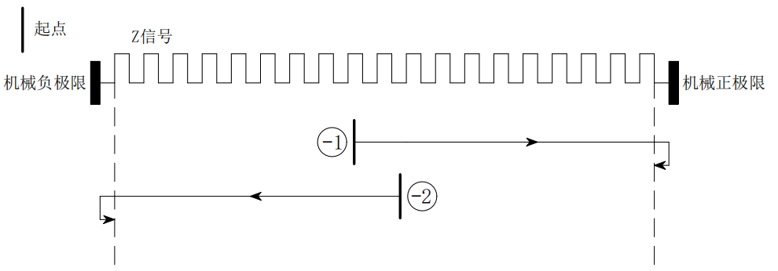

5.5.2 Method-3 and Method-4
Mode-3 is "locked rotor return to zero type", the entire action is as follows:
The driver receives'Return to origin enable signal'After the command,'Return to origin speed V1','Return to origin acceleration and deceleration time'Several parameters start to move, and after a stall occurs, they decelerate to a stop and move in the reverse direction. After the dynamic torque of the motor disappears, they decelerate to a stop, and this position is used as the origin, and the entire return to zero action is completed.
Mode-4 is similar to Mode-3, except that the running direction is opposite, which will not be described in detail here.
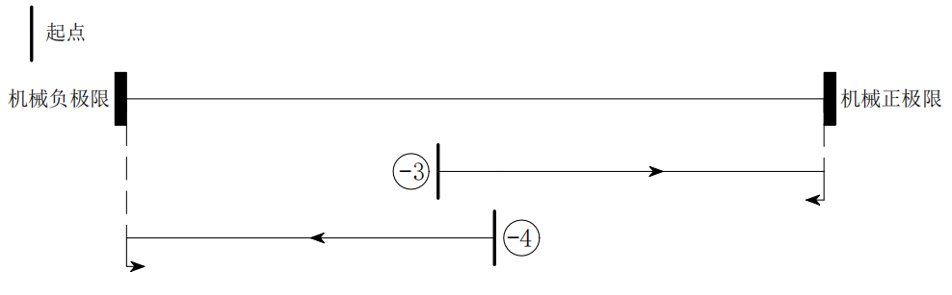

5.5.3 Method-5 and Method-6
Mode-5 is "locked rotor return to zero type", the entire action is as follows:
The driver receives'Return to origin enable signal'After the command,'Return to origin speed V1','Return to origin acceleration and deceleration time'Several parameters start to move, and when a stall occurs, they stop immediately, and the position is used as the origin, and the entire return to zero action is completed.
Mode-6 is similar to Mode-5, except that the running direction is opposite, which will not be described in detail here.
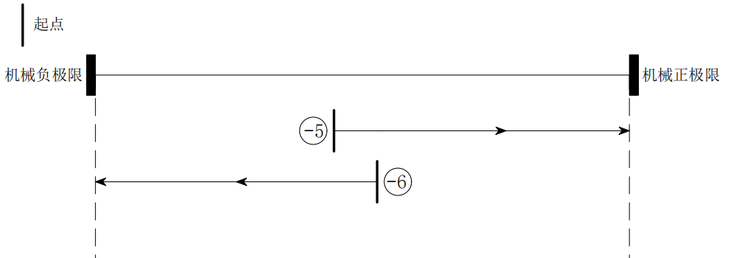

5.5.4 Method 1 and Method 2
Mode 1 is similar to Mode 17, except that the turning back deceleration point is the first Z signal after the negative limit signal.
Mode 2 is similar to Mode 18, except that the turning deceleration point is the first Z signal after the positive limit signal.
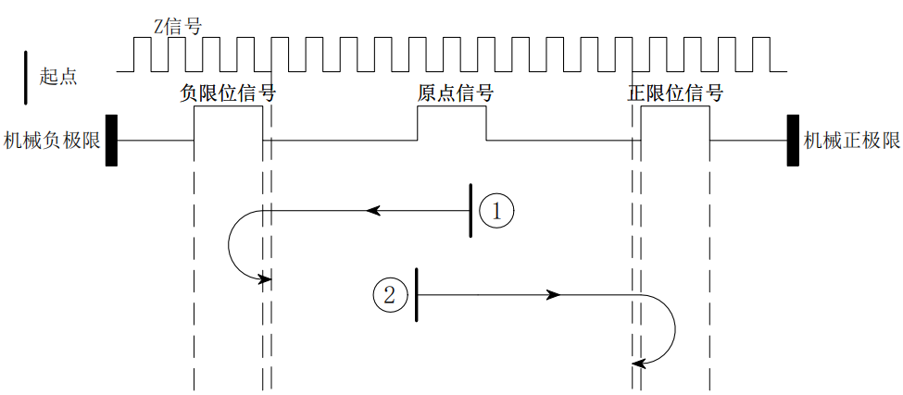

5.5.5 Method 3 and Method 4
Mode 3 is similar to Mode 19, except that the return deceleration point is the first Z signal outside the origin signal.
Mode 4 is similar to Mode 20, except that the turning deceleration point is the first Z signal after the origin signal.
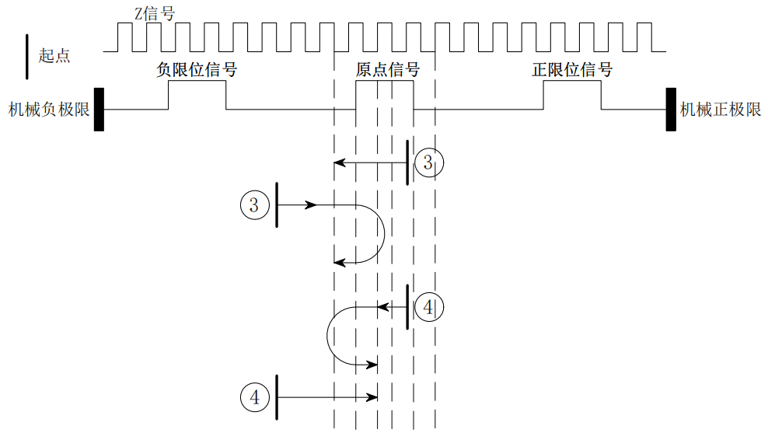

5.5.6 Method 5 and Method 6
Mode 5 is similar to Mode 21, except that the return deceleration point is the first Z signal outside the origin signal.
Mode 6 is similar to Mode 22, except that the turning deceleration point is the first Z signal in the origin signal.
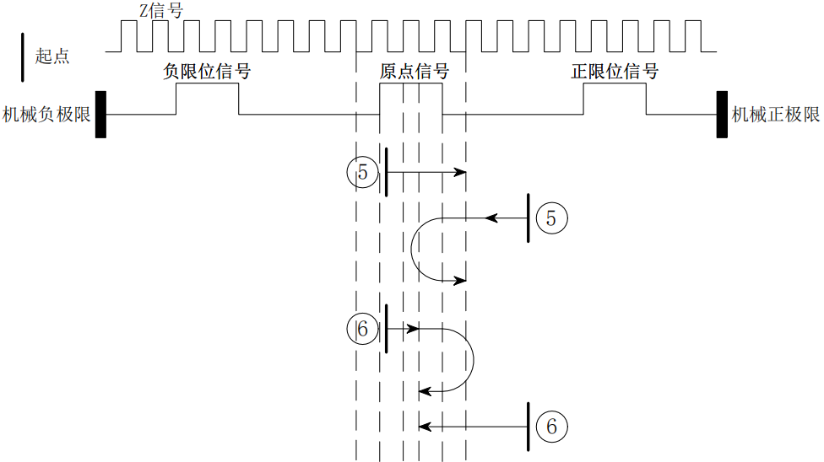

5.5.7 Method 7 and Method 8
Mode 7 is similar to Mode 23, except that the return deceleration point is the first Z signal outside the origin signal.
Mode 8 is similar to Mode 24, except that the return deceleration point is the first Z signal in the origin signal.
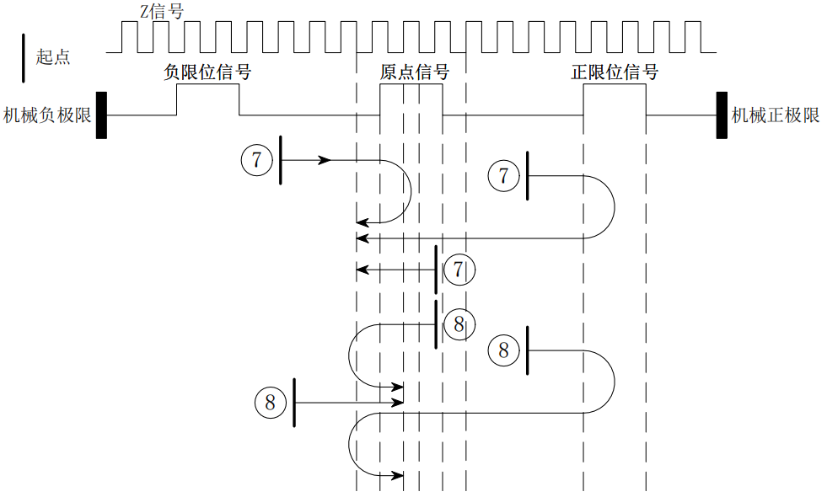

5.5.8 Method 9 and Method 10
Mode 9 is similar to Mode 25, except that the return deceleration point is the first Z signal in the origin signal.
Mode 10 is similar to Mode 26, except that the turning deceleration point is the first Z signal outside the origin signal.
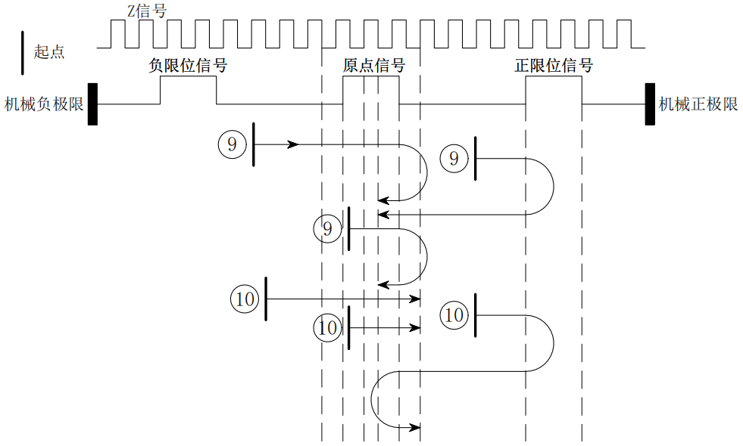

5.5.9 Method 11 and Method 12
Mode 11 is similar to Mode 27, except that the turning deceleration point is the first Z signal outside the origin signal.
Mode 12 is similar to Mode 28, except that the turning deceleration point is the first Z signal in the origin signal.
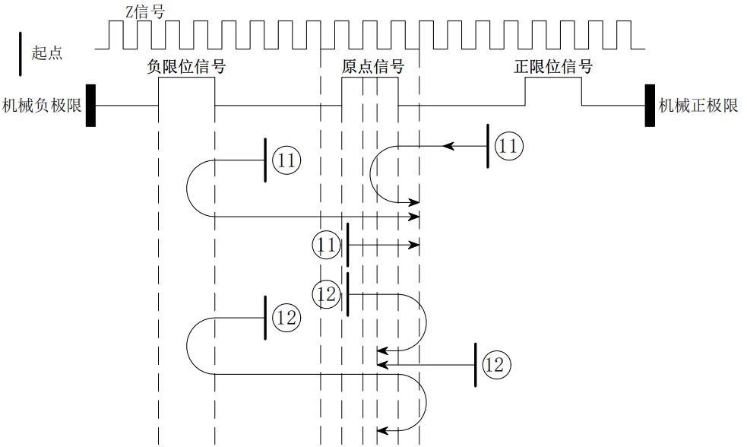

5.5.10 Method 13 and Method 14
Mode 13 is similar to Mode 29, except that the turning deceleration point is the first Z signal in the origin signal.
Mode 14 is similar to Mode 30, except that the turning deceleration point is the first Z signal outside the origin signal.
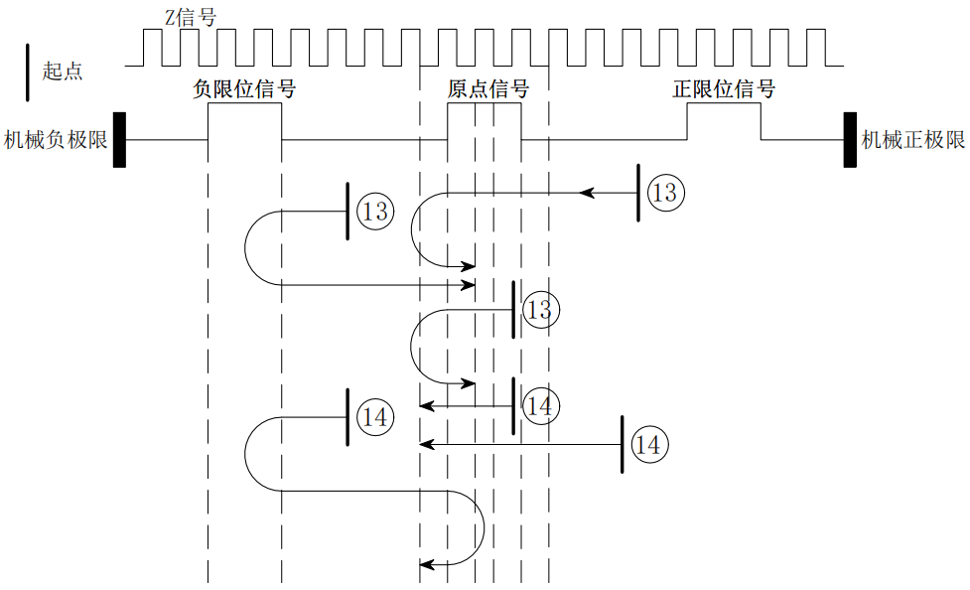

5.5.11 Way17and methods18
Mode 17 is "negative limit return to zero", and the origin stop position is at the negative limit signal.
'Negative limit return to zero'The whole action is divided into two cases, as follows:
Case A: The driver receives'Return to origin enable signal'After the command,'Return to origin speed V1','Return to origin acceleration and deceleration time'Several parameters start to move, and when encountering the rising edge of the limit signal, it decelerates and stops.'The return to origin speed V2' runs in the opposite direction until it encounters the falling edge of the limit signal, then decelerates and stops, and the entire return to zero action is completed.
Case B: The driver receives'Return to origin enable signal'After the command is given, if the position is within the limit, the'Return to origin speed V2','Return to origin acceleration and deceleration time'The parameter starts to move, and when it encounters the falling edge of the limit signal, it decelerates and stops, and the entire return to zero action is completed.
Mode 18 is "positive limit return to zero", and the origin stop position is at the positive limit signal. It is similar to mode 17, except that the running direction is opposite, which will not be explained in detail here.
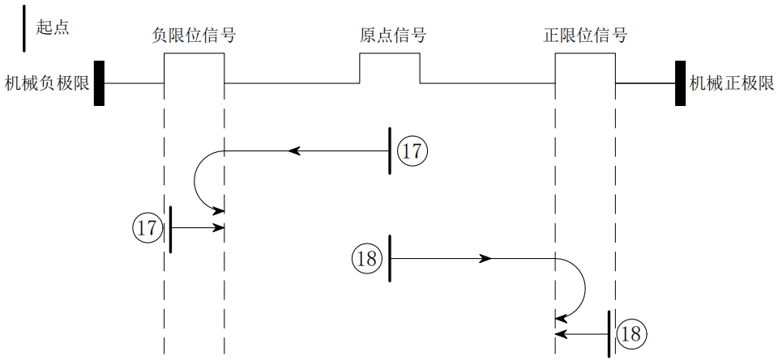

5.5.12 Method 19 and Method 20
The origin stop position of mode 19 is on the left side of the rising edge of the origin signal in the positive direction.
The entire action of method 19 is divided into two cases, as follows:
Case A: The driver receives'Return to origin enable signal'After the command,'Return to origin speed V1','Return to origin acceleration and deceleration time'Several parameters move in the positive direction, and when they encounter the rising edge of the origin signal, they decelerate and stop.'The return to origin speed V2' runs in the opposite direction until it encounters the falling edge of the origin signal, then decelerates and stops, and the entire return to zero action is completed.
Case B: The driver receives'Return to origin enable signal'After the command is given, if the device is in the origin signal, it will'Return to origin speed V2','Return to origin acceleration and deceleration time'Several parameters move in the opposite direction. When they encounter the falling edge of the origin signal, they decelerate and stop, and the entire return to zero action is completed.
The origin stop position of mode 20 is on the right side of the rising edge of the origin signal in the positive direction, which is similar to mode 19 and will not be described in detail here.
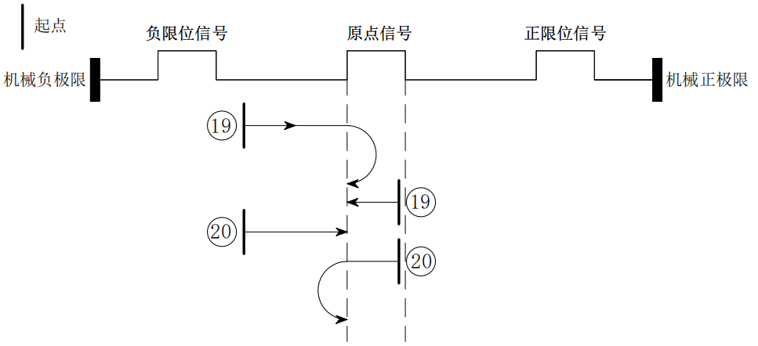

5.5.13 Method 21 and Method 22
The origin stop position of method 21 is on the right side of the rising edge of the origin signal in the reverse direction, and the origin stop position of method 22 is on the left side of the rising edge of the origin signal in the reverse direction. Similar to method 21, detailed description is not given here.
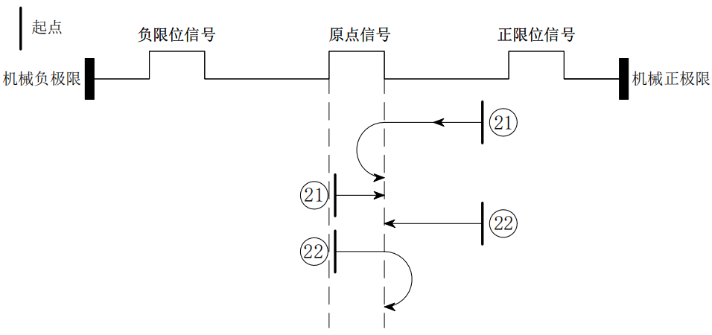

5.5.14 Method 23 and Method 24
The origin stop position of mode 23 is on the left side of the rising edge of the origin signal in the positive direction.
The entire action of method 23 is divided into three cases, as follows:
Case A: The driver receives'Return to origin enable signal'After the command,'Return to origin speed V1','Return to origin acceleration and deceleration time'Several parameters move in the positive direction, and when they encounter the rising edge of the origin signal, they decelerate and stop.'The return to origin speed V2' runs in the opposite direction until it encounters the falling edge of the origin signal, then decelerates and stops, and the entire return to zero action is completed.
Case B: The driver receives'Return to origin enable signal'After the command,'Return to origin speed V1','Return to origin acceleration and deceleration time'Several parameters move in the positive direction and stop immediately when encountering the rising edge of the positive limit signal.'The return to origin speed V2' runs in the opposite direction until it encounters the falling edge of the origin signal, then decelerates and stops, and the entire return to zero action is completed.
Case C: The driver receives'Return to origin enable signal'After the command is given, if the device is in the origin signal, it will'Return to origin speed V2','Return to origin acceleration and deceleration time'Several parameters move in the opposite direction. When they encounter the falling edge of the origin signal, they decelerate and stop, and the entire return to zero action is completed.
The origin stop position of mode 24 is on the right side of the rising edge of the origin signal in the positive direction, which is similar to mode 23 and will not be described in detail here.
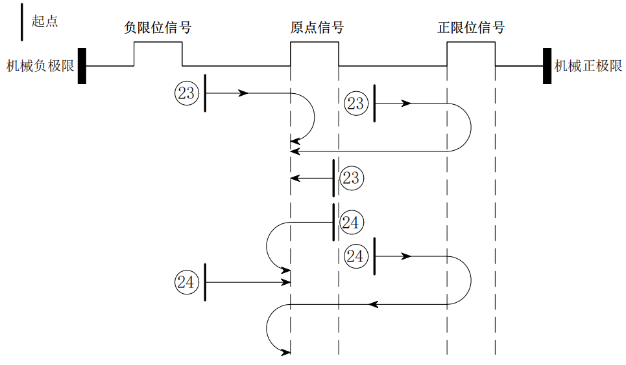

5.5.15 Method 25 and Method 26
The origin stop position of mode 25 is on the left side of the falling edge of the origin signal in the positive direction.
The entire action of method 25 is divided into three cases, as follows:
Case A: The driver receives'Return to origin enable signal'After the command,'Return to origin speed V1','Return to origin acceleration and deceleration time'Several parameters move in the positive direction. When encountering the rising edge of the origin signal, they continue to run. When encountering the falling edge of the origin signal, they slow down and stop.'The return to origin speed V2' runs in the opposite direction until it encounters the rising edge of the origin signal, then decelerates and stops, and the entire return to zero action is completed.
Case B: The driver receives'Return to origin enable signal'After the command,'Return to origin speed V1','Return to origin acceleration and deceleration time'Several parameters move in the positive direction and stop immediately when encountering the rising edge of the positive limit signal.'The return to origin speed V2' runs in the opposite direction until it encounters the rising edge of the origin signal, then decelerates and stops, and the entire return to zero action is completed.
Case C: The driver receives'Return to origin enable signal'After the command is given, if the device is in the origin signal, it will'Return to origin speed V1','Return to origin acceleration and deceleration time'Several parameters move in the positive direction, and when they encounter the falling edge of the origin signal, they decelerate and stop.'The return to origin speed V2' runs in the opposite direction until it encounters the rising edge of the origin signal, then decelerates and stops, and the entire return to zero action is completed.
The origin stop position of mode 26 is on the right side of the falling edge of the origin signal in the positive direction, which is similar to mode 25 and will not be described in detail here.
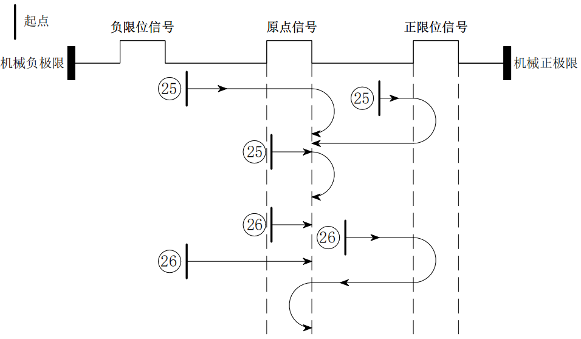

5.5.16 Method 27 and Method 28
The origin stop position of mode 27 is on the right side of the rising edge of the origin signal in the opposite direction. The entire action is similar to that of mode 25, except that the initial running direction is opposite.
The origin stop position of mode 28 is on the left side of the rising edge of the origin signal in the opposite direction. The entire action is similar to that of mode 26, except that the initial running direction is opposite.
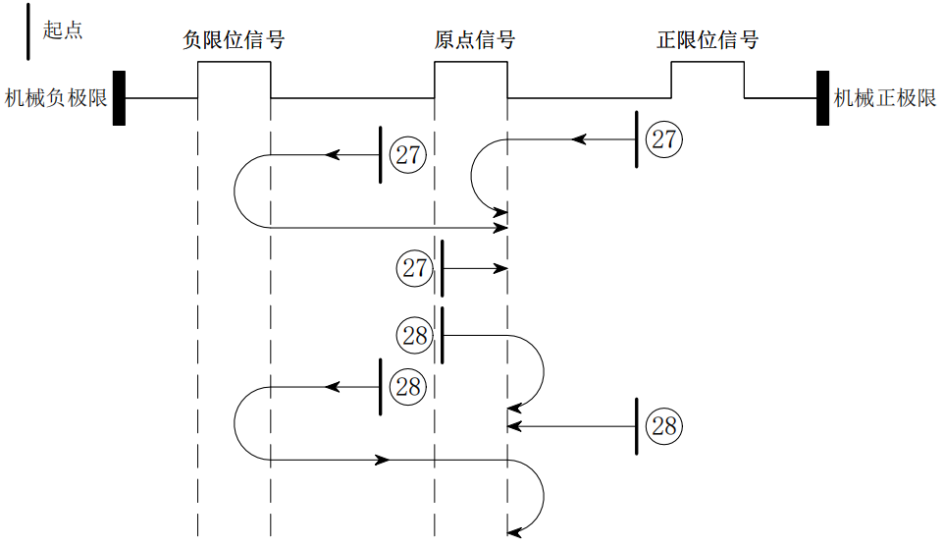

5.5.17 Method 29 and Method 30
The origin stop position of mode 29 is on the right side of the falling edge of the origin signal in the opposite direction.'Similar to method 27, except that the initial running direction is opposite.
The origin stop position of mode 29 is on the left side of the falling edge of the origin signal in the opposite direction. The entire action is similar to that of mode 28, except that the initial running direction is opposite.
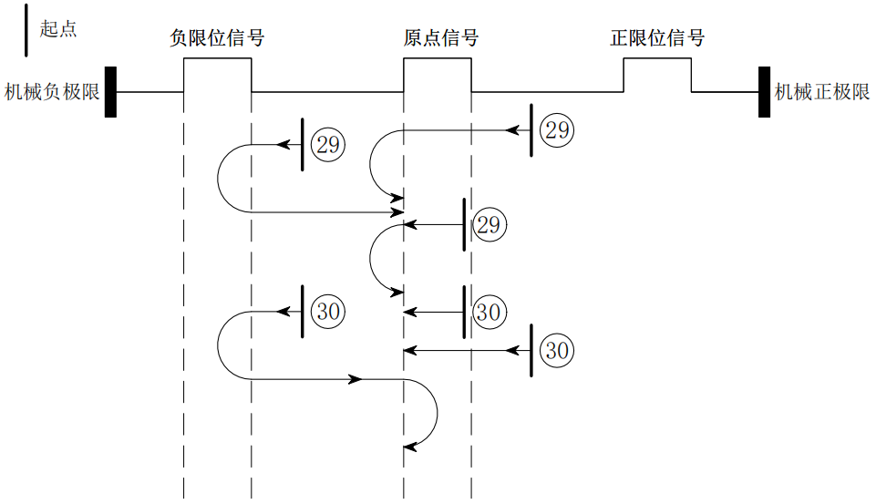

5.5.18 Method 33 and Method 34
Mode 33 uses the Z signal as the zero return detection signal, which is consistent with the direction of mode 17. The origin stop position is on the right side of the Z signal.
Mode 34 uses the Z signal as the zero return detection signal, which is consistent with the direction of mode 18. The origin stop position is on the left side of the Z signal.

5.5.19 Method 35 and Method 37
Methods 35 and 37 take the current position as the zero point.

6.Fault codes and indicator lights

6.1 Drive Failure
0x603F/0x2707Code | 0x1001Code | 0x2706Configuration | Can it be cleared? | meaning | Flashing red light | Flashing green light
0x2211 | 0x04 | Bit1 | no | Busbar undervoltage | 1 | 1
0x3211 | 0x04 | Bit1 | no | Busbar overvoltage | 1 | 2
0x4211 | 0x04 | Bit5 | no | Driver overtemperature | 1 | 3
0x5110 | 0x80 | Bit4 | no | Motor phase A is missing | 1 | 4
0x5120 | 0x80 | Bit4 | no | Motor B phase is missing | 1 | 5
0x7329 | 0x80 | - | yes | Limit alarm | 2 | 1
0x8401 | 0x20 | - | no | Position out of tolerance | 2 | 2
0x8402 | 0x20 | - | yes | Command overspeed | 2 | 3
0x8403 | 0x20 | - | yes | The pulse increment is too large within the PWM cycle | 2 | 4
0x5530 | 0x80 | Bit2 | yes | EEPROM parameter initialization error | 3 | 1
0x5531 | 0x80 | Bit2 | yes | EEPROM hardware error | 3 | 2
0x5532 | 0x80 | Bit2 | yes | Failure in saving communication parameters | 3 | 3
0x5533 | 0x80 | Bit2 | yes | Failure to save manufacturer parameters | 3 | 4
0x5534 | 0x80 | Bit2 | yes | Saving 402 parameter failure | 3 | 5

Writing 1 to 0x2708 can clear the current alarm; writing 1 to 0x2709 can clear the fault record, that is, clear the fault list of 0x2707;

6.2 ECAT communication alarm
According to the ECAT ALM status code definition, some error codes are listed below. The alarm code type is 0x82xx and uses a unified LED flashing combination;
0x603F/0x2707Code | 0x1001Code | Can it be cleared? | meaning | Flashing red light | Flashing green light
0x8215 | 0x10 | yes | Invalid BOOT mode configuration | 4 | 1
0x8213 | 0x10 | yes | No BOOT support | 4 | 1
0x8216 | 0x10 | yes | Invalid mailbox configuration | 4 | 1
0x8217 | 0x10 | yes | Invalid SM configuration | 4 | 1
0x821B | 0x10 | yes | SM watchdog timeout | 4 | 1
0x821C | 0x10 | yes | Invalid SM type | 4 | 1
0x821D | 0x10 | yes | Invalid output configuration | 4 | 1
0x821E | 0x10 | yes | Invalid input configuration | 4 | 1
0x821F | 0x10 | yes | Invalid watchdog configuration | 4 | 1
0x821A | 0x10 | yes | Synchronous mode error | 4 | 1
0x8230 | 0x10 | yes | Invalid DC configuration | 4 | 1
0x8232 | 0x10 | yes | DC PLL Error | 4 | 1
0x8233 | 0x10 | yes | DC synchronous IO error | 4 | 1
0x8234 | 0x10 | yes | DC synchronization timeout | 4 | 1
0x8211 | 0x10 | yes | Invalid state change request | 4 | 1
0x8212 | 0x10 | yes | Unknown state change request | 4 | 1
0x8221 | 0x10 | yes | The slave needs to be in the Init state | 4 | 1
0x8222 | 0x10 | yes | The slave needs to be in Pre-Op state | 4 | 1
0x8223 | 0x10 | yes | The slave needs to be in Safe-OP state | 4 | 1

6.3 Troubleshooting
0x603F/0x2707 Alarm code: 0x3211, busbar overvoltage or undervoltage
reason | Confirmation method | Treatment measures
The power input of the driver is too low | Measure the voltage between the VDC and GND terminals of the driver | Make the driver work within the specified voltage range
The power input of the driver is too low | Measure the voltage between the VDC and GND terminals of the driver | Make the driver work within the specified voltage range
Driver pump boost voltage is too high | / | Reduce acceleration and deceleration
The drive power cable is loose | / | The driver power cable is connected normally.

0x603F/0x2707 alarm code: 0x4211,Driver overtemperature
reason | Confirmation method | Treatment measures
Drive overload | / | Confirm the load size corresponding to the driver
Ambient temperature is too high | Use a thermometer to test the ambient temperature | Make the driver work within the specified temperature range

0x603F/0x2707 alarm code: 0x5110, 0x5120,Motor A and B phases are missing
reason | Confirmation method | Treatment measures
Motor A or B phase is missing | Check whether the motor wiring is correct | The driver motor wires are connected normally

0x603F/0x2707 alarm code: 0x7329,Limit alarm
reason | Confirmation method | Treatment measures
CSP, PP, PV mode, hardware positive limit or hardware negative limit action | Check bit 0 and bit 1 of 0x60FD through the host computer or master station | When the polarity of the driver IO input is consistent with the external switch type (normally open or normally closed), it is normal limit protection;  If the polarity of the driver's IO input is inconsistent with the external switch type, you need to modify the driver's IO input polarity or change the external switch type (normally open or normally closed).
CSP, PP, PV mode, software positive limit or software negative limit action | Check whether 0x6064 is within the range of 0x607D:01 and 0x607D:02 through the host computer or master station. | Software limit protection operates normally

0x603F/0x2707 alarm code:0x8401, location out of range
reason | Confirmation method | Treatment measures
Encoder resolution setting error | If the code 0x8401 is reported at the start of the operation, the encoder resolution may be set incorrectly. | Modify the encoder resolution through the host computer or master software, save the parameters, and restart the drive to take effect.
Motor terminals A+ A- B+ B- wiring error | If the alarm 0x8401 is reported when the machine starts running, it may be due to the wiring of the motor power line. Check whether the wiring sequence of the A+ A- B+ B- terminals is correct. | Make sure terminals A+ A- B+ B- are wired correctly
The motor is stalled | If the error 0x8401 is reported during operation, it is likely that the motor is stuck and the error is caused by the motor. | Check whether the mechanical structure operates smoothly;  Check the load size and appropriately increase the output current, increase the power supply voltage, and reduce the operating speed;  Check whether the running motor line and encoder line are loose
Encoder abnormality | Check whether the encoder is working properly | Replace the same closed loop motor and see if it works properly.

0x603F/0x2707 alarm code:0x8402, command overspeed
reason | Confirmation method | Treatment measures
The driver subdivision does not correspond to the single-turn pulse number of the master station | Determine the number of single-turn pulses of the master and the number of subdivisions of the driver | Modify the number of single-turn pulses of the driver and the master station through the host computer or master station software, or modify the number of single-turn pulses of the master station and the number of subdivisions of the driver.
The synchronization period set by the master station is actually greater than the synchronization period of the drive operation | Check the synchronization cycle size set on the master station, and  Monitors the synchronization cycle size of the slave network | Modify the synchronization period set by the master station to be less than or equal to  Equal to the drive's synchronization period (can be monitored by the master station or host computer)

0x603F/0x2707 alarm code:0x8403,The pulse increment is too large within the PWM cycle
reason | Confirmation method | Treatment measures
The acceleration of the drive is too large | / | Reduce drive acceleration

0x603F/0x2707 alarm code: 0x5530, 0x5531,0x5532, 0x5533, 0x5534, EEPROMFailure to save parameters
reason | Confirmation method | Treatment measures
Software anomaly | Is it possible to restore factory settings? | Restore factory parameter settings via host computer or master station (0x1011)
Drive damage | Can be saved several times | Replace the drive with a new one

0x603F/0x2707 Alarm code: 0x82xx, ECAT communication alarm
reason | Confirmation method | Treatment measures
ECAT communication abnormality | Whether the ESC master station is working properly;  Whether the number of control axes of the ESC master station is within the specified range;  Is the network cable connection normal?  Is the XML file version correct?  Whether the PDO channel settings are normal;  Is there significant communication interference in the working environment? | Replace the ESC master station;  The number of control axes of the ESC master station is within the specified range;  Use Category 5e or above shielded network cables;  The XML file version is consistent;  The PDO channel settings are correct;  Suitable working environment

Serial port download parameter description
For details, please refer to the document "ECA1 Series Serial Port Download Communication Protocol Manual".

Warranty and after-sales

8.1 Warranty

8.1.1 Free warranty
Our company solemnly promises that all our products will be repaired free of charge for one year if they are damaged during use. The shipping costs will be borne by both parties.

8.1.2 Warranty Exclusion
- The driver is damaged due to the customer's own wiring errors;
- The driver is damaged due to exceeding the rated working voltage;
- The DC power supply driver is connected to the AC power supply, causing damage to the driver;
- The driver is damaged due to the customer's on-site environment being extremely harsh, such as humidity, extreme cold, extreme heat, etc., without informing our company in advance;
- The customer has dismantled the drive casing without authorization or the serial number label has been torn off;
- 15 days after the customer confirms receipt, the casing is obviously damaged or impacted, resulting in damage to the drive;
- Force majeure natural disasters, such as fire, earthquake, tsunami, typhoon, etc.;
In the above cases, our company will charge a certain amount of repair cost after evaluating the interests of all parties. In other cases, the repair will be free of charge forever.

8.2 Exchange

8.2.1 Product Replacement for Faulty Products
For any faults that occur in new products, our company provides a three-month free replacement service.
Once our technical support staff confirms that the problem is with the product itself, they will ship the product back to us to avoid wasting time and postage. Customers must first return the faulty product by courier or logistics. Upon receipt, we will promptly ship a replacement product to the customer.
Notice:All our products undergo rigorous testing and aging before leaving the warehouse, so it is extremely rare for new products to malfunction. Please be sure to read the instructions carefully or consult our technical support staff when operating, or our technical support staff will assist customers remotely with operation.
- Please note the following points when exchanging goods:
(1) Please ensure that the package is complete when returning to avoid damage during transportation;
(2) Please ensure that the attached accessories are complete when exchanging the product;
(3) Each driver should be packaged independently in its original outer box to avoid secondary damage to the product during transportation;
(4) If the driver is returned and it is confirmed that the fault is not due to product failure, but is caused by the customer's negligence in operation, which mistakenly believes that the driver is faulty, the company will not bear the shipping fee (the customer's negligence includes: wrong wiring resulting in damage to the driver, poor wiring resulting in the driver being damaged, operating errors resulting in the driver being unable to operate normally, etc.).

8.2.2 Exchange for non-product failure
If you are dissatisfied with the appearance or functionality of the product you received and would like to exchange it for a superior driver, you can request a replacement within one week of receiving the product. After verification, we will return the product and, upon confirmation that the returned product is undamaged, has all accessories, and is well packaged, we will replace it with another product. If there is a price difference between the replacement product and the replacement product, the customer will pay the difference.
Note: The replaced product will no longer be eligible for the non-product fault replacement service. The round-trip shipping costs and other expenses incurred by the non-product fault replacement service are borne by the customer!

8.3 Returns
Our company provides a 7-day return service for products with quality problems. If you find any quality problems with the product itself within 7 days of receiving the product (based on the actual date of receipt by the customer), please communicate with our salesperson or technical support personnel in a timely manner. After our technical support personnel confirms that it is a quality problem with the company's product itself, the customer can send the original complete product and its inner and outer packaging, accessories and shipping order back to our company by express delivery or logistics.
If the customer still insists on returning the goods after our company has checked and confirmed that they are correct, the round-trip shipping costs and all other expenses incurred shall be borne by the customer.
- Please note the following points when returning products:
(1) Please contact the relevant department of our company before making a refund;
(2) The product must be in new condition and intact packaging. Please send it back to our company by express or logistics;
(3) We will not accept any complaints caused by customers, such as product appearance damage, incomplete accessories, etc.

8.4 After-sales Service
If customers encounter technical problems when using this product, please contact our company as soon as possible. Please call our national toll-free service hotline: 0755-23206995.
Service hours: Monday to Saturday 8:30-17:30 (except national holidays).

9.Version Revision History
Version number | illustrate | Modification deadline | Preparer/Reviewer
V1.0.0 | ECA1 series initial instruction manual version; | 2025.6.20 | LRQ/TCJ
V1.0.1 | CIA402 parameter 606C speed unit is corrected to rpm, 607D name is corrected toOrigin offset position; | 2025.8.8 | LRQ/TCJ
V1.0.2 | 0x2300 Open-loop operation peak current setting description errata | 2025.8.22 | LRQ/TCJ
V1.0.3 | Separate the over-voltage and under-voltage alarms; | September 19, 2025 | LRQ/TCJ

